Behavior Pact
Insert School Name

----------------------------------------------------------------------

Behavior Pact is a collaborative and goal-oriented program that helps teachers and students work together to establish long and short-term goals to build skills and mastery of school-wide expectations.

_______________________ has been nominated to participate in Behavior Pact!

Here’s how it works: Teacher & student co construct attainable and measurable goals for learning/demonstrating expected behaviors with support from parents. Broad long-term goals are chunked into daily and weekly goals and feedback between teacher and student is provided at the end of each day. As part of this process, students and teachers also develop strategies/supports that the teacher will provide encourage and pre-corrective feedback. Teachers and students also develop re-enforcements that can be earned by the student for meeting their goals.

Here are some strategies for supporting Behavior Pact in the classroom:

- Consistency: Staying true to the Pact will be key. Use the Feedback/Supports co-constructed together and avoid giving too much attention to the student in the initial stages of the Pact.

- Focusing on strengths: Build your feedback to students off what they do well. As students begin to implement the Pact it will take time for them change behavior patterns. Provide encourage and focus on strengths and successes!

- Positive praise: Remember, you get more of what you see and notice. When student is meeting their goal behavior, or you’re seeing them really try hard at it, notice it and voice it when appropriate.

On the back, please see an example of a Behavior Pact:
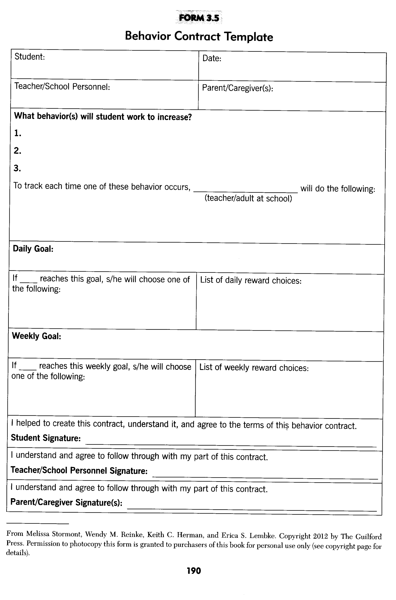

___________________________ will work with you and (insert student) develop a Behavior Pact that will work best for you and your students.

